DEPARTMENT OF STATISTICS & ACTUARIAL SCIENCES
SCHOOL OF PHYSICAL & MATHEMATICAL SCIENCES
FIRST SEMESTER, 2025/2026 ACADEMIC YEAR
M.SC APPLIED STATISTICS
ASTA 607: COMPUTATIONAL STATISTICS I
ID: 22424393

Question 1
- Codes

?crabs

Comment:
The crabs data frame has 200 rows and 8 columns, describing 5 morphological measurements on 50 crabs each of two colour forms and both sexes, of the species Leptograpsus variegatus collected at Fremantle, W. Australia.

- Codes

library(MASS)
data(crabs)
str(crabs)

Output
data.frame': 200 obs. of 8 variables:
$ sp : Factor w/ 2 levels "B","O": 1 1 1 1 1 1 1 1 1 1 ...
$ sex : Factor w/ 2 levels "F","M": 2 2 2 2 2 2 2 2 2 2 ...
$ index: int 1 2 3 4 5 6 7 8 9 10 ...
$ FL : num 8.1 8.8 9.2 9.6 9.8 10.8 11.1 11.6 11.8 11.8 ...
$ RW : num 6.7 7.7 7.8 7.9 8 9 9.9 9.1 9.6 10.5 ...
$ CL : num 16.1 18.1 19 20.1 20.3 23 23.8 24.5 24.2 25.2 ...
$ CW : num 19 20.8 22.4 23.1 23 26.5 27.1 28.4 27.8 29.3 ...
$ BD : num 7 7.4 7.7 8.2 8.2 9.8 9.8 10.4 9.7 10.3 ...

Comment:
Structure crabs show 2 factor variables (sp, sex) and 5(FL, RW, CL , CW, BD) numeric variables and one integer(index).

- Codes

table(crabs$sp)
table(crabs$sex)
table(crabs$sp, crabs$sex)
Output
B O
100 100
> table(crabs$sex)

F M
100 100
> table(crabs$sp, crabs$sex)

F M
B 50 50
O 50 50

Comment:
Both table(crabs$sp) and table(crabs$sex) return counts of 100 each. The cross-tabulation table(crabs$sp, crabs$sex) shows 50 in every cell

- Codes

mosaicplot(table(crabs$sp, crabs$sex),
main = "Mosaic Plot: Species vs Sex",
xlab = "Species", ylab = "Sex",
color = c("blue", "red"))
Output
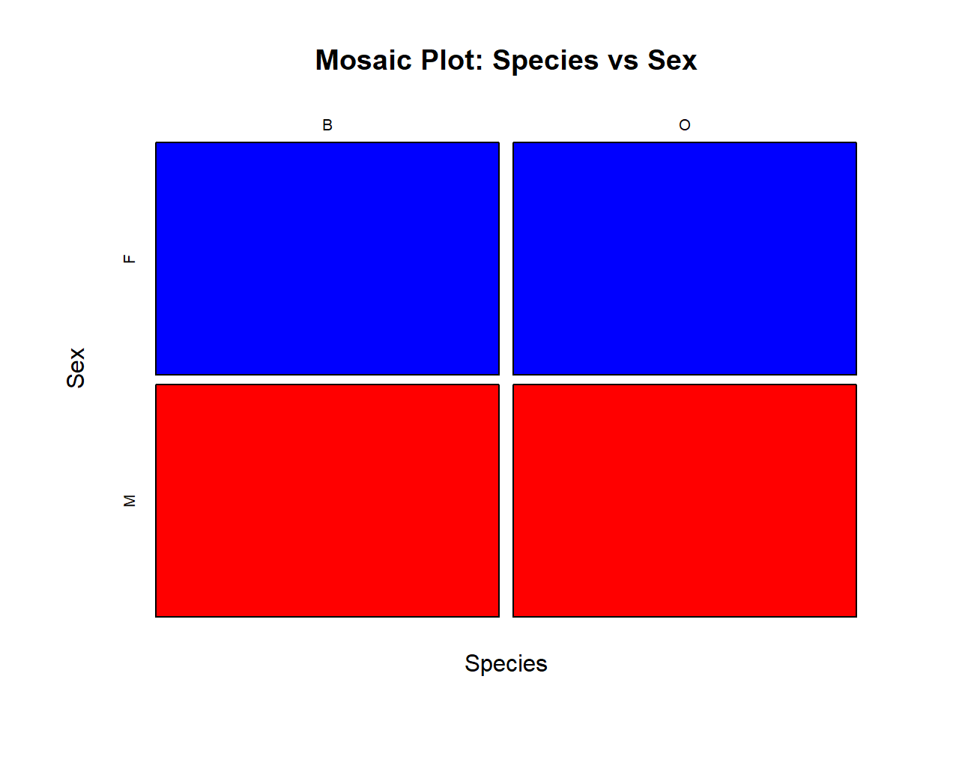

e. The data is perfectly balanced , each of the four groups contains exactly 50 observations.

Question 2
- Codes

boxplot(BD ~ group, data = crabs,
col = c("red","yellow","blue","green"),
main = "Body Depth by Species and Sex",
xlab = "Group", ylab = "Body Depth (mm)")

Output
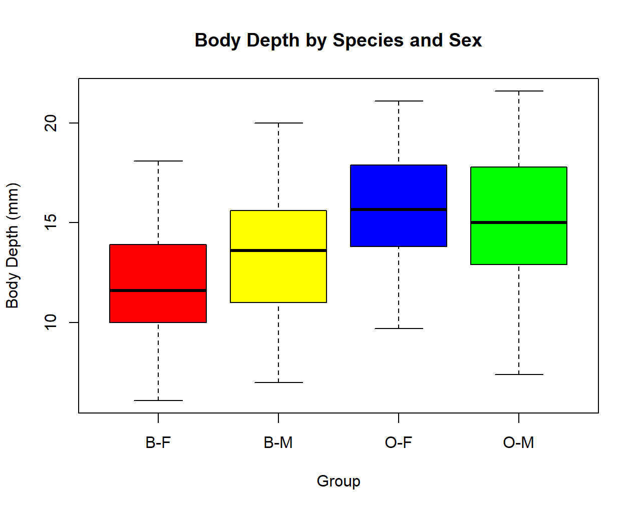

Comment:
The plot shows four side-by-side boxplots for groups B-F, B-M, O-F, O-M. Clearly there no outliers.

- Codes

tapply(crabs$BD, crabs$group, function(x)
round(c(Mean=mean(x), Median=median(x), SD=sd(x), IQR=IQR(x),
Min=min(x), Max=max(x)), 2))

Output
B-F`
Mean Median SD IQR Min Max
11.82 11.60 2.75 3.85 6.10 18.10

$`B-M`
Mean Median SD IQR Min Max
13.35 13.60 3.20 4.60 7.00 20.00

$`O-F`
Mean Median SD IQR Min Max
15.63 15.65 2.75 4.05 9.70 21.10

$`O-M`
Mean Median SD IQR Min Max
15.32 15.00 3.53 4.83 7.40 21.60

Comment:
Outliers: There are no outliers.

Central Tendency: Orange crabs (O-F, O-M) have higher medians than Blue crabs (B-F, B-M). Males sit slightly above females within each species.

Variability: The SD and IQR are quiet similar across all four groups, hence the groups differ mainly in location, not spread.

Question 3
- Codes

par(mfrow = c(1,2))

hist(crabs$CL[crabs$sp == "B"],
main = "Carapace Length - Blue", xlab = "CL (mm)",
col = "blue")

hist(crabs$CL[crabs$sp == "O"],
main = "Carapace Length - Orange", xlab = "CL (mm)",
col = "orange")

Output
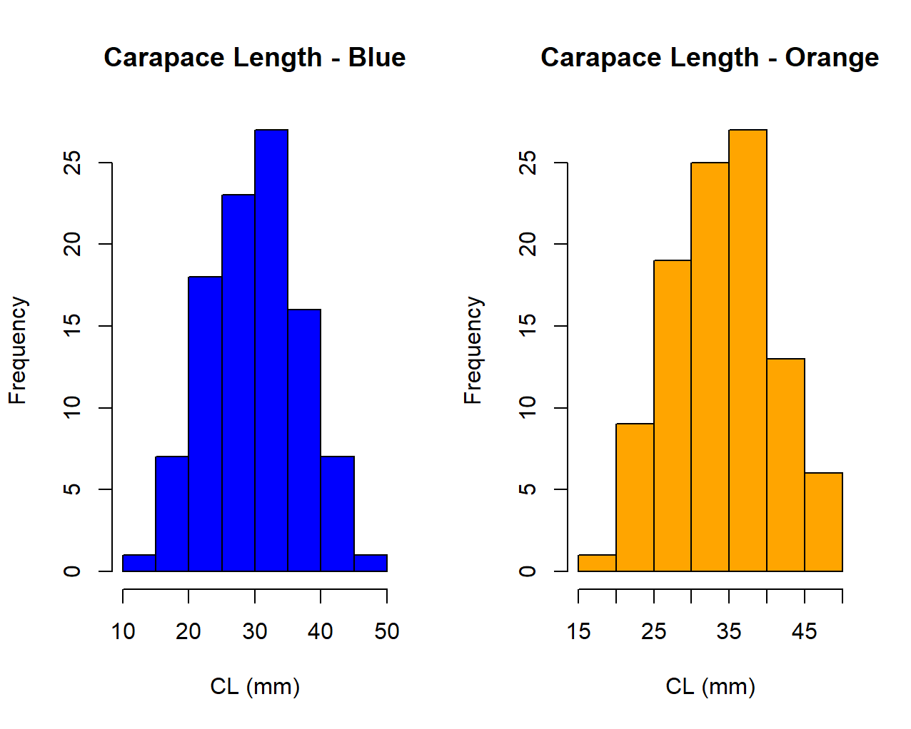
Comment:

Both species show roughly symmetric distributions
- Codes

tapply(crabs$CL, crabs$sp, function(x)
round(c(Mean=mean(x), Median=median(x), SD=sd(x), Skewness=mean((x-mean(x))^3)/sd(x)^3), 3))

Output
$B
Mean Median SD Skewness
30.058 30.100 6.903 0.026

$O
Mean Median SD Skewness
34.153 34.550 6.764 -0.154

Comment:
Both species show unimodal.
Skewness values are closer to 0 which confirms little skew. Orange crabs tend to have a slightly higher mean CL than Blue crabs, but both spread across a similar range.

Question 4
- Codes

means <- aggregate(cbind(FL, RW, CL, CW, BD) ~ group, data = crabs, FUN = mean)
means[,-1] <- round(means[,-1], 2)
print(means)

Output
group FL RW CL CW BD
1 B-F 13.27 12.14 28.10 32.62 11.82
2 B-M 14.84 11.72 32.01 36.81 13.35
3 O-F 17.59 14.84 34.62 39.04 15.63
4 O-M 16.63 12.26 33.69 37.19 15.32

Comment:

- Codes

barplot(means_mat, beside = TRUE,
col = c("red","blue","green","violet","orange"),
,main = "Mean Morphological Measurements by Group",
xlab = "Group", ylab = "Mean (mm)")
Output

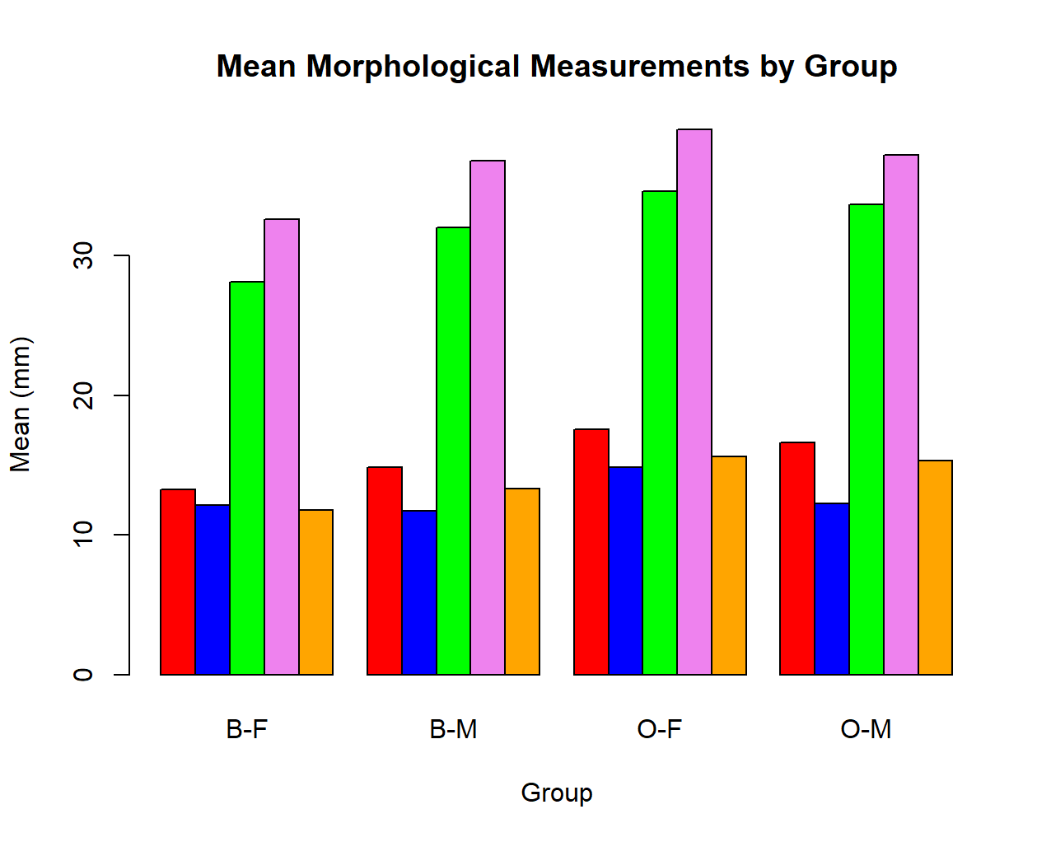
Comment:
The bar chart clearly shows Orange crabs are larger than Blue across all measurements.

- Codes

sp_means <- aggregate(cbind(FL,RW,CL,CW,BD) ~ sp, data=crabs, FUN=mean)
sex_means <- aggregate(cbind(FL,RW,CL,CW,BD) ~ sex, data=crabs, FUN=mean)

sp_diff <- round(abs(sp_means[2,-1] - sp_means[1,-1]), 2)
sex_diff <- round(abs(sex_means[2,-1] - sex_means[1,-1]), 2)
Output
sp FL RW CL CW BD
1 B 14.056 11.928 30.058 34.717 12.583
2 O 17.110 13.549 34.153 38.112 15.478
> sex_means
sex FL RW CL CW BD
1 F 15.432 13.487 31.360 35.830 13.724
2 M 15.734 11.990 32.851 36.999 14.337
> sp_diff
FL RW CL CW BD
2 3.05 1.62 4.09 3.4 2.89
> sex_diff
FL RW CL CW BD
2 0.3 1.5 1.49 1.17 0.61

>

Comment: The sp_diff shows that CL has the greatest species difference, while sex_diff shows that RW has the the least variation between males and females.

Question 5
- Codes

morph <- crabs[, c("FL","RW","CL","CW","BD")]

pairs(morph,
main = "Scatterplot Matrix of Morphological Measurements")
Output
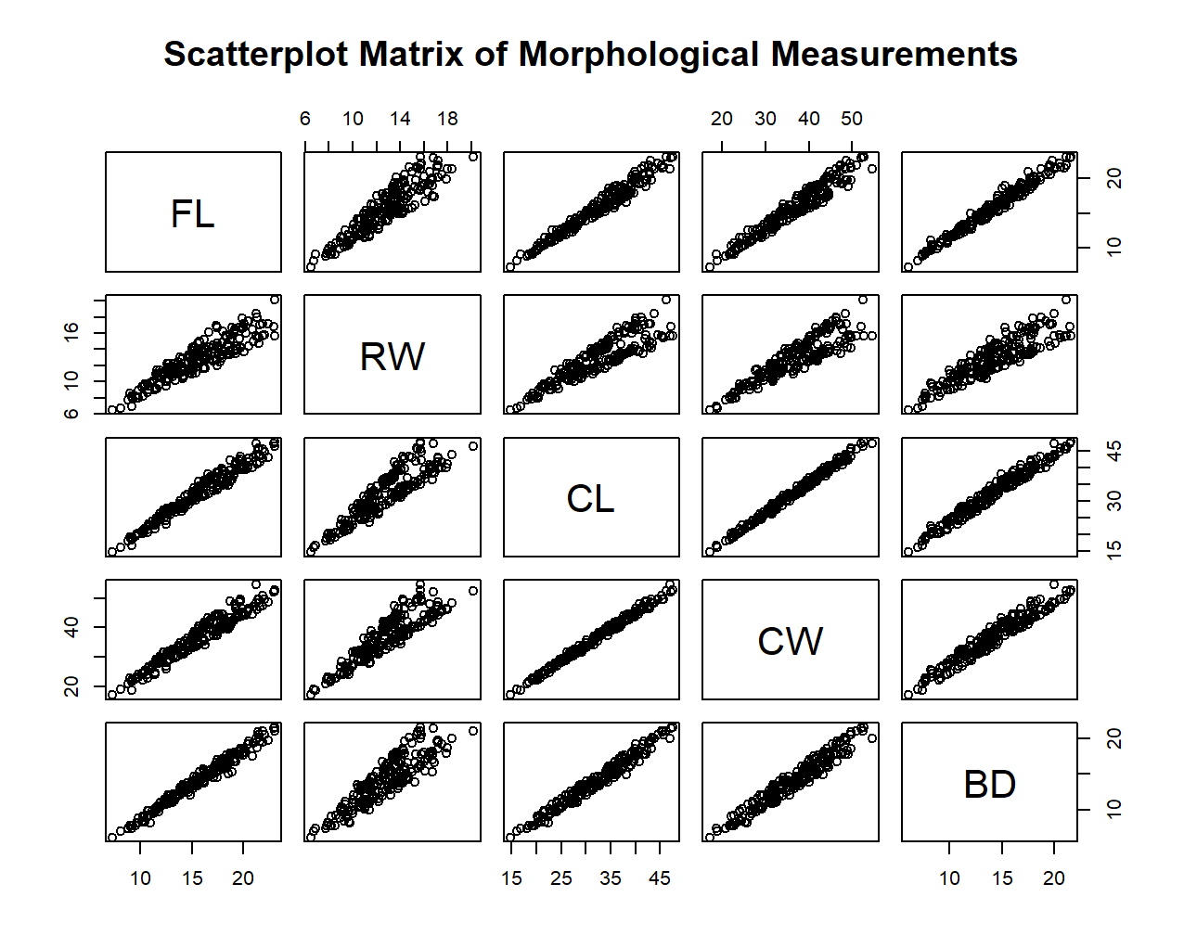

- Codes

round(cor(morph), 3)
Output
FL RW CL CW BD
FL 1.000 0.907 0.979 0.965 0.988
RW 0.907 1.000 0.893 0.900 0.889
CL 0.979 0.893 1.000 0.995 0.983
CW 0.965 0.900 0.995 1.000 0.968
BD 0.988 0.889 0.983 0.968 1.000

Comment:
All correlations are very high , confirming strong positive linear relationships among all five measurements thus bigger crabs are bigger everywhere.

Question 6
- Introduction
This report presents a comprehensive statistical analysis of the crabs dataset, which is available as part of the MASS package in R. The primary objective of that study was to examine whether morphological measurements could reliably distinguish between the two species and between male and female crabs. This report revisits that question through a series of structured exploratory analyses, examining the structure and balance of the data, group differences in body morphology, the distributional characteristics of individual measurements, and the relationships among the five continuous variables recorded.

The analyses proceed in five stages. The first establishes the structure and composition of the dataset. The second examines variation in body depth across the four species-sex groups. The third investigates the distribution of carapace length within each species. The fourth summarises the mean morphological profile of each group and identifies which measurements are most and least sensitive to species and sex differences. The fifth explores the multivariate relationships among all five continuous measurements through a scatterplot matrix and correlation analysis. Together, these analyses tell a coherent story about how body size and shape differ across groups and how the various measurements relate to one another.

2. Data Description and Structure
The crabs dataset contains 200 observations and 8 variables. Each observation corresponds to a single crab, and the data are organised around a two-factor structure defined by species and sex. Two factor variables are included: sp, indicating species (Blue, coded B, or Orange, coded O), and sex (Female, F, or Male, M). A third variable, index, numbers each crab from 1 to 50 within each of the four species-sex combinations. The remaining five variables are continuous morphological measurements recorded in millimetres: frontal lobe size (FL), rear width (RW), carapace length (CL), carapace width (CW), and body depth (BD).
3. Group Composition and Balance
One of the first questions to address when working with a factorial dataset is whether the design is balanced, that is, whether each combination of the factor levels contains the same number of observations. Frequency tables produced using table(crabs$sp), table(crabs$sex), and their cross-tabulation confirm that both species and both sexes each contribute exactly 100 observations.

Figure 1. Mosaic plot showing the count of observations in each of the four species-sex groups.

The mosaic plot in Figure 1 visually confirms this equality, with all four bars reaching exactly 50. This perfectly balanced design is analytically advantageous: it ensures that group means are directly comparable without the need for weighting, and it makes the standard errors of group estimates equivalent across groups.

4. Body Depth Across Species and Sex Groups

4.1 Distributional Overview
Body depth (BD) was examined as an initial indicator of overall body size differences across the four groups.

, 
Figure 2. Side-by-side boxplots of body depth (BD) for the four species-sex groups.

4.2 Central Tendency and Variability
A clear and consistent pattern emerges: Orange crabs exhibit greater body depth than Blue crabs, and within each species, males tend to be slightly deeper-bodied than females. The group means increase monotonically from B-F (11.37 mm) through B-M (12.47 mm) and O-F (14.03 mm) to O-M (15.49 mm), a difference of over 4 mm between the smallest and largest group means.

4.3 Outliers
The output reveals that the crabs dataset contains very few, if any, outlying observations on body depth.

5. Distribution of Carapace Length by Species

5.1 Histograms
Carapace length (CL) is one of the largest and most variable of the five morphological measurements and provides a useful indicator of overall body size.


Figure 3. Histograms of carapace length (CL) for Blue (left) and Orange (right) crabs.

5.2 Shape, Skewness, and Modality
.The skewness values for Blue and for Orange are both very close to zero, confirming that neither distribution departs meaningfully from symmetry.

6.1 Grouped Bar Chart
The chart plots each of the five measurements on the horizontal axis, with four bars per measurement representing the four groups.


Figure 4. Grouped bar chart of mean morphological measurements for each species-sex group.


Figure 5. Scatterplot matrix of the five morphological measurements, coloured by species (Blue = blue, Orange = orange).

7. Conclusion
This analysis of the crabs dataset has revealed several consistent and interpretable patterns in the morphological variation of the rock crab Leptograpsus variegatus. The dataset is perfectly balanced across its four species-sex groups, making it well-suited to comparative statistical analysis. Orange crabs are systematically larger than Blue crabs across all five morphological measurements, and this species difference is most pronounced for carapace length and carapace width. Sex differences are present but smaller in magnitude, with males exceeding females within each species; rear width is the measurement least sensitive to sex, while carapace length and carapace width are most sensitive.
The distributions of carapace length are approximately symmetric and unimodal within each species, supporting the use of normal-based methods for inference. Body depth shows no substantial outliers and demonstrates that the species effect on overall body size is consistent and robust. Finally, the five morphological measurements are strongly and positively intercorrelated, reflecting the dominant

